Project Design Phase-II Data flow Diagram

|  |  |
| --- | --- |
| Date | 17 November 2022 |
| Name | SANDTHIYA S |
| Team ID | Team ID : PNT2022TMID49204 |
| Project Name | Project - Natural disaster intensity analysis and Classification using AI |
|  |  |

Data Flow Diagrams:

A data flow diagram (DFD) is a visual representation of the information flow through a process or system. DFDs help you better understand process or system operation to discover potential problems, improve efficiency, and develop better processes

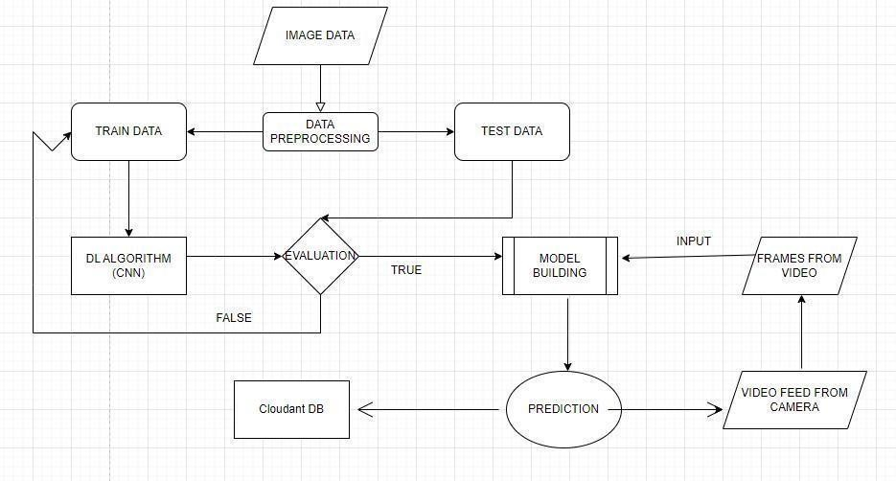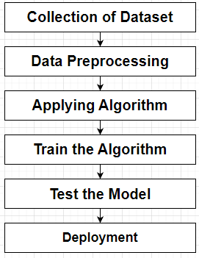

Example: DFD Level 0 (Industry Standard)